MODULE 1 : SQL SERVER 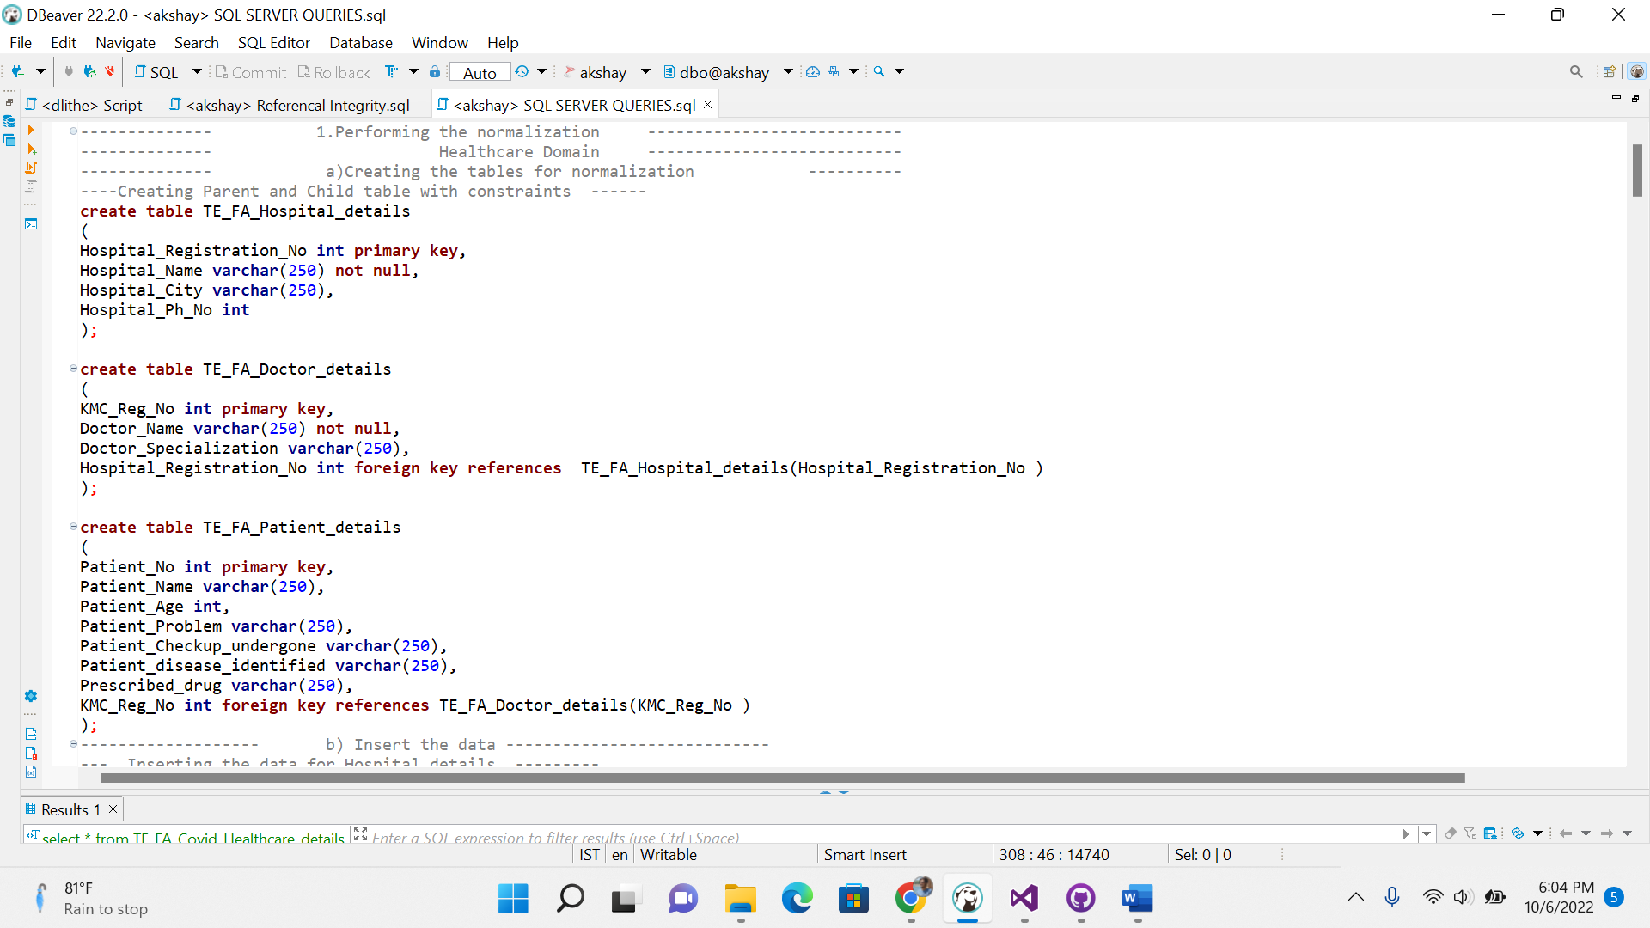

Table creation for the Normalisation :

1.Hospital details

2.Doctor details

3.Patient details

Each table is normalized with using the primary keys and foreign keys and the constraints. This is like Hospital_Registration_No is the primary key in TE_FA_Hospital_details table and foreign key in TE_FA_Doctor_details . (TE_FA_Hospital_details (parent)- TE_FA_Doctor_details (child)).

Inserting the data into created tables.

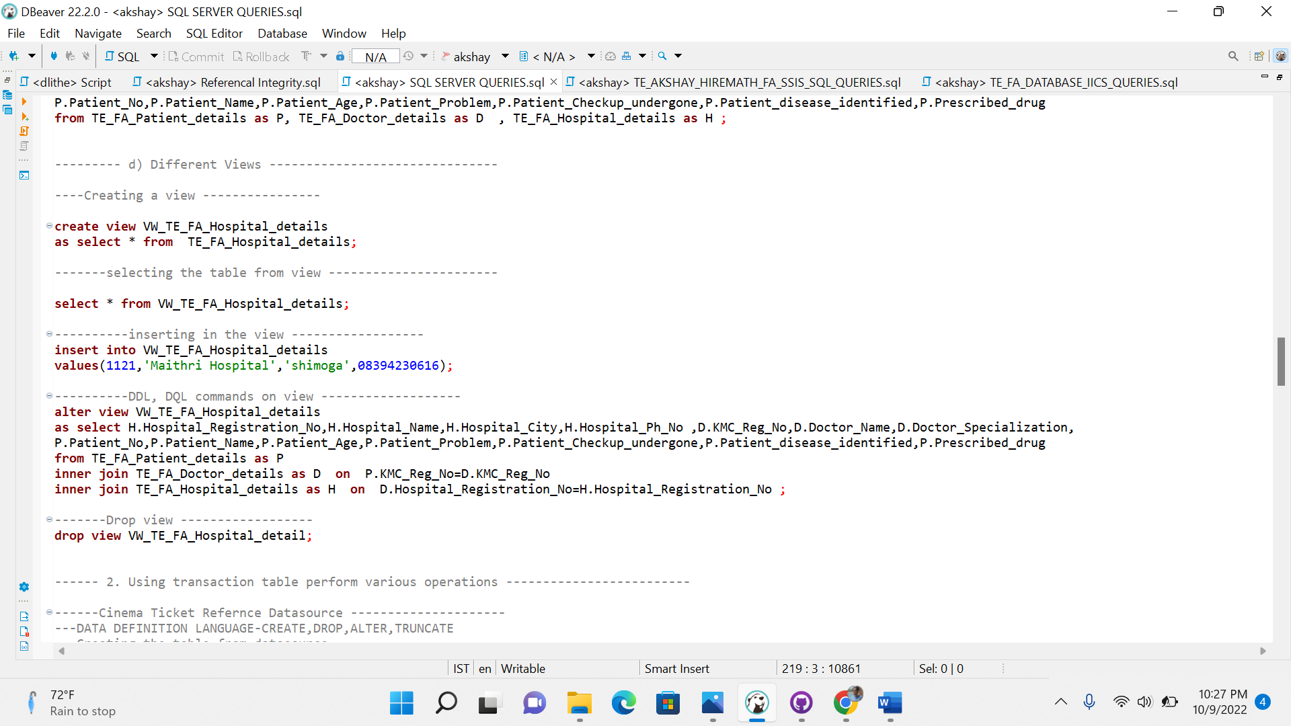

Different type of views- creating the views , selecting , inserting all the queries.

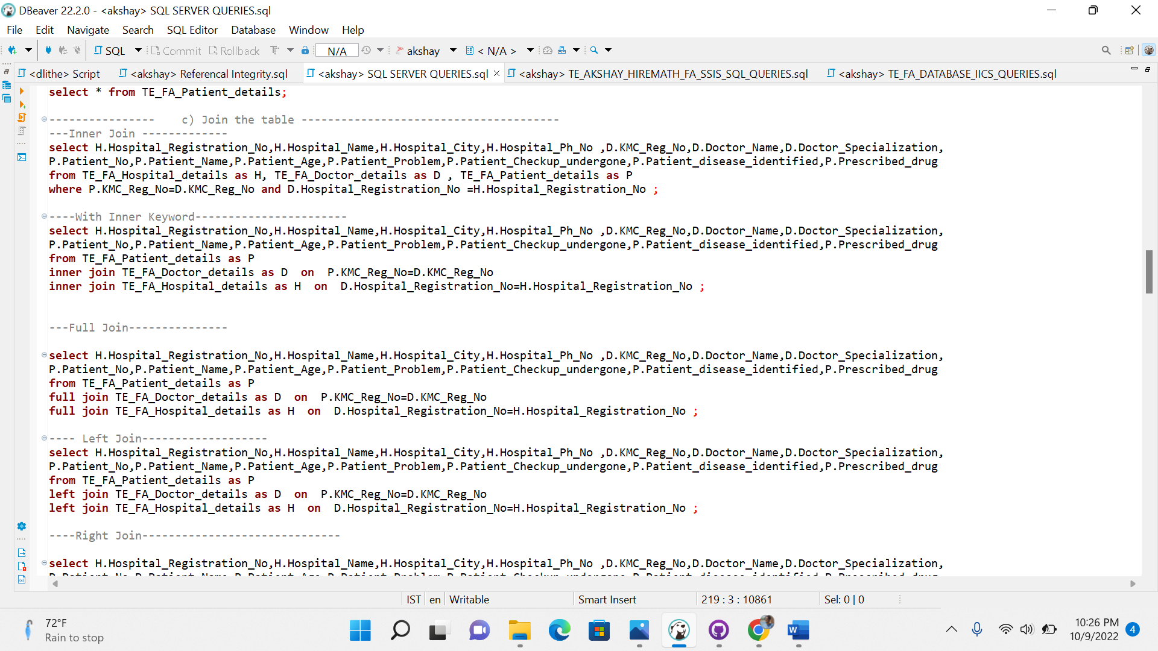

Joins queries which are performed on tables.

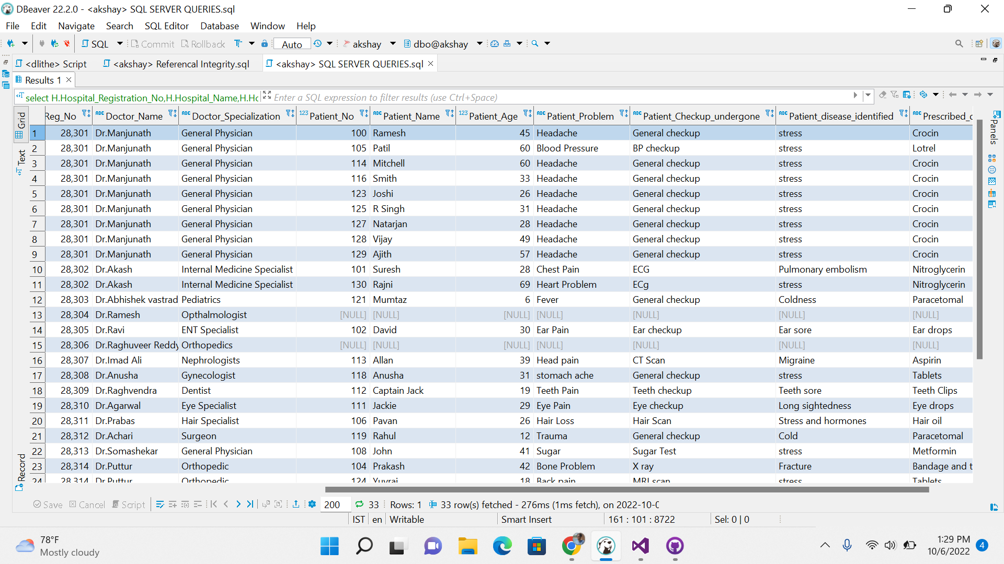

1.Right Join: In the right join Doctor who are there but didn’t check any off the patients also will be displayed.

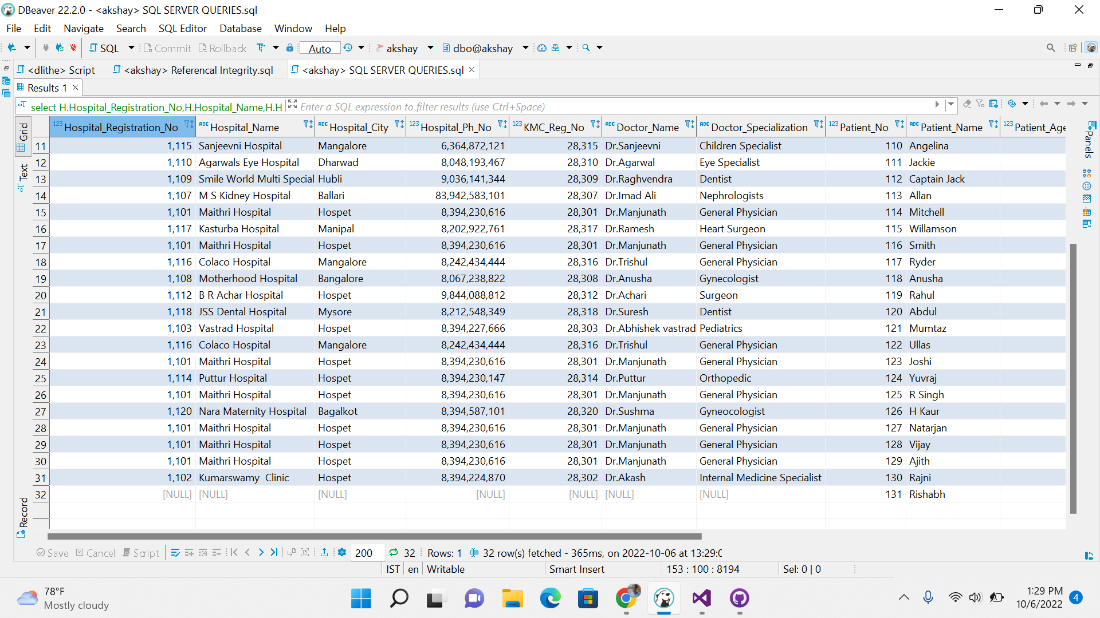2.Left Join : In the left join the Patient who have checked up with doctor who is not in doctor column also will be displayed with other patients.

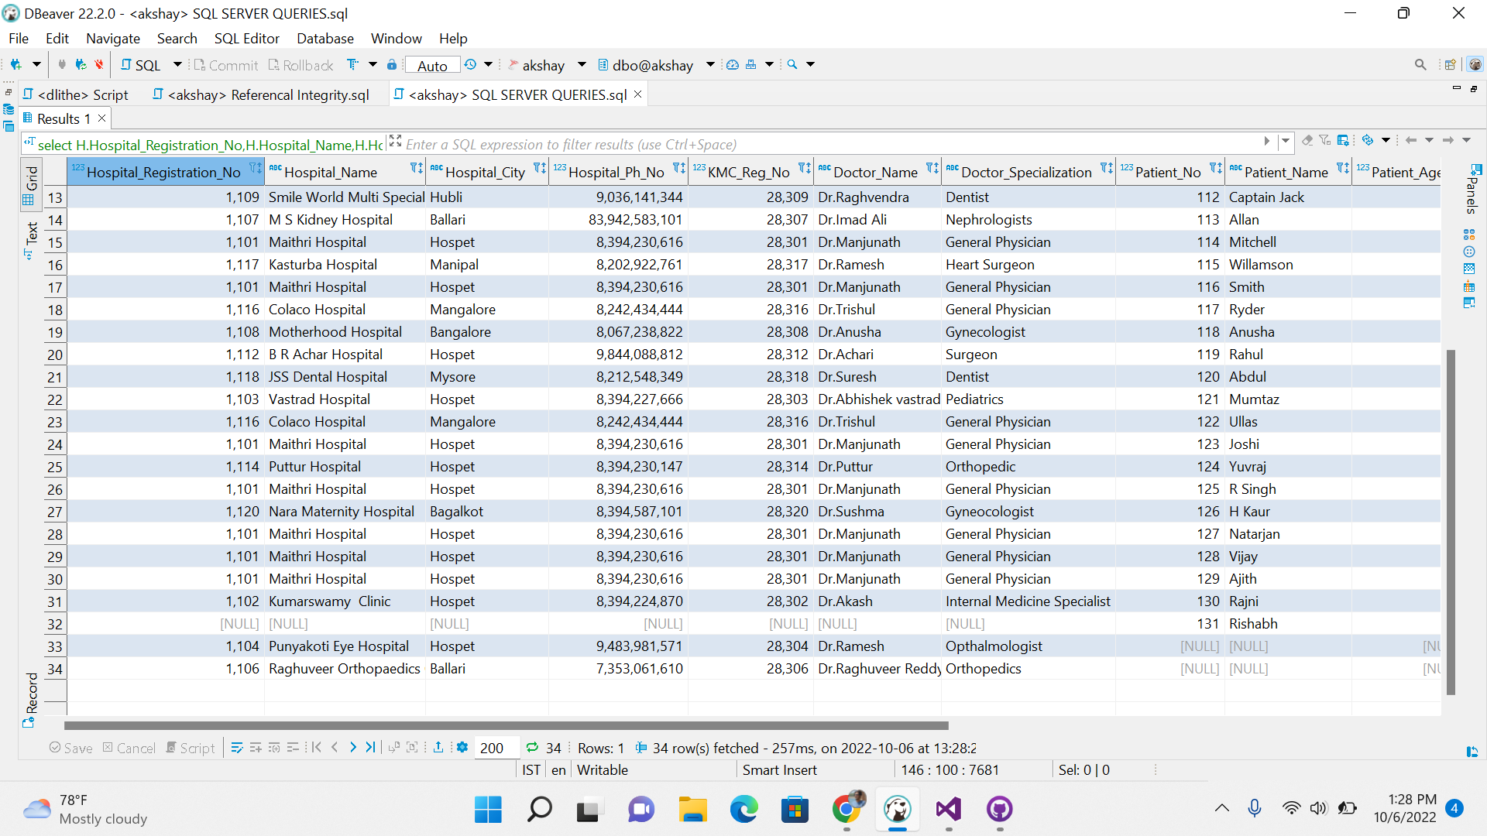

3.Inner Join Output: In the Inner join all the data will be in the table without null values.

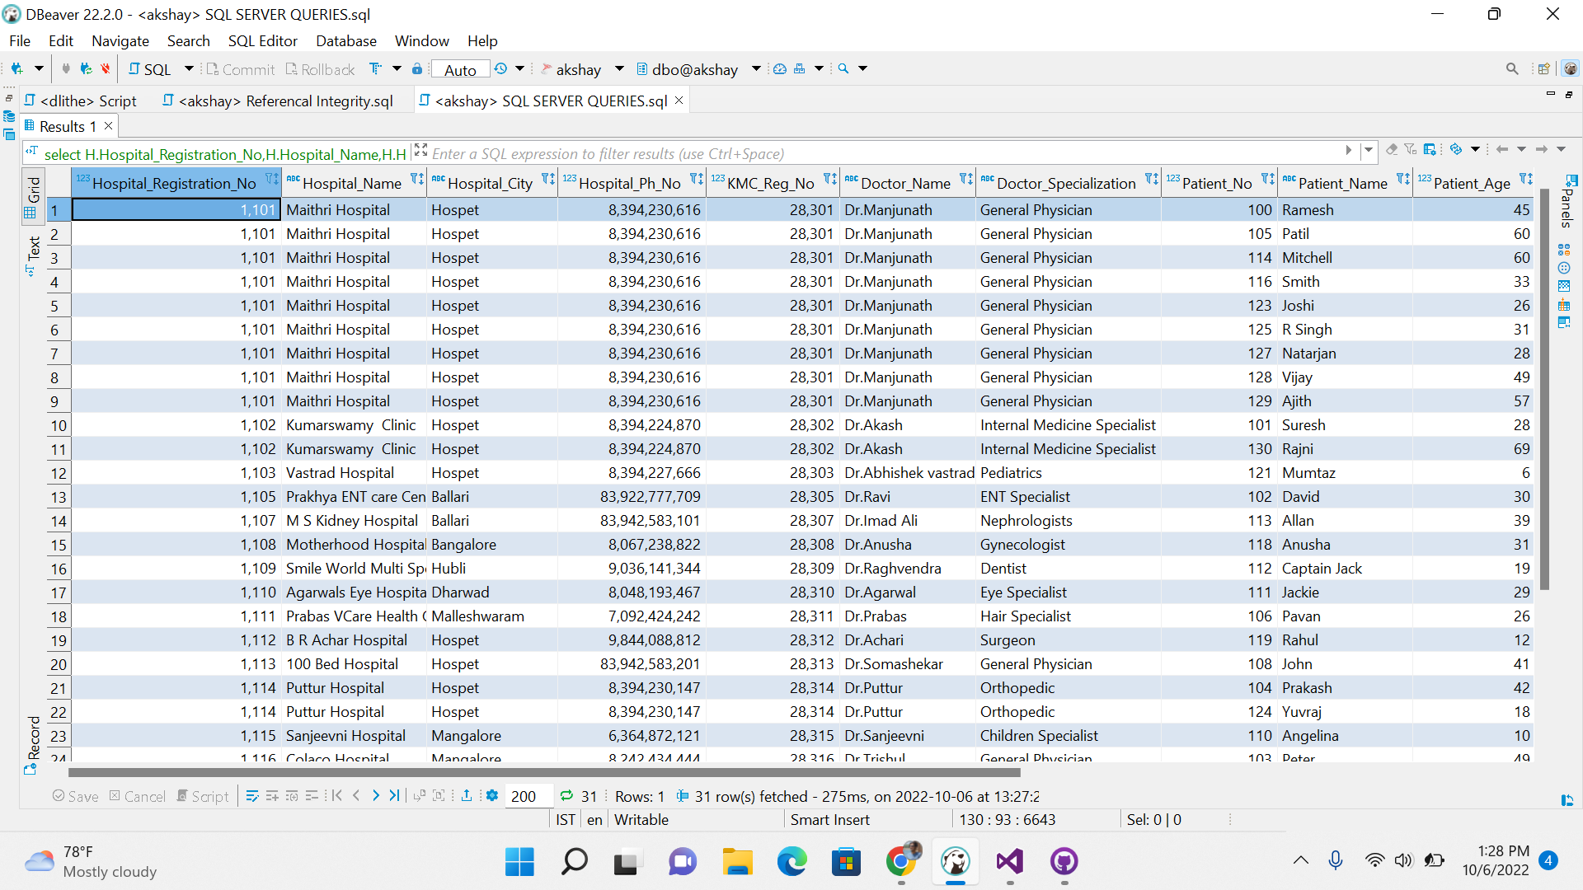4.Full Join : In the full join every data will be come in the output with the null values.

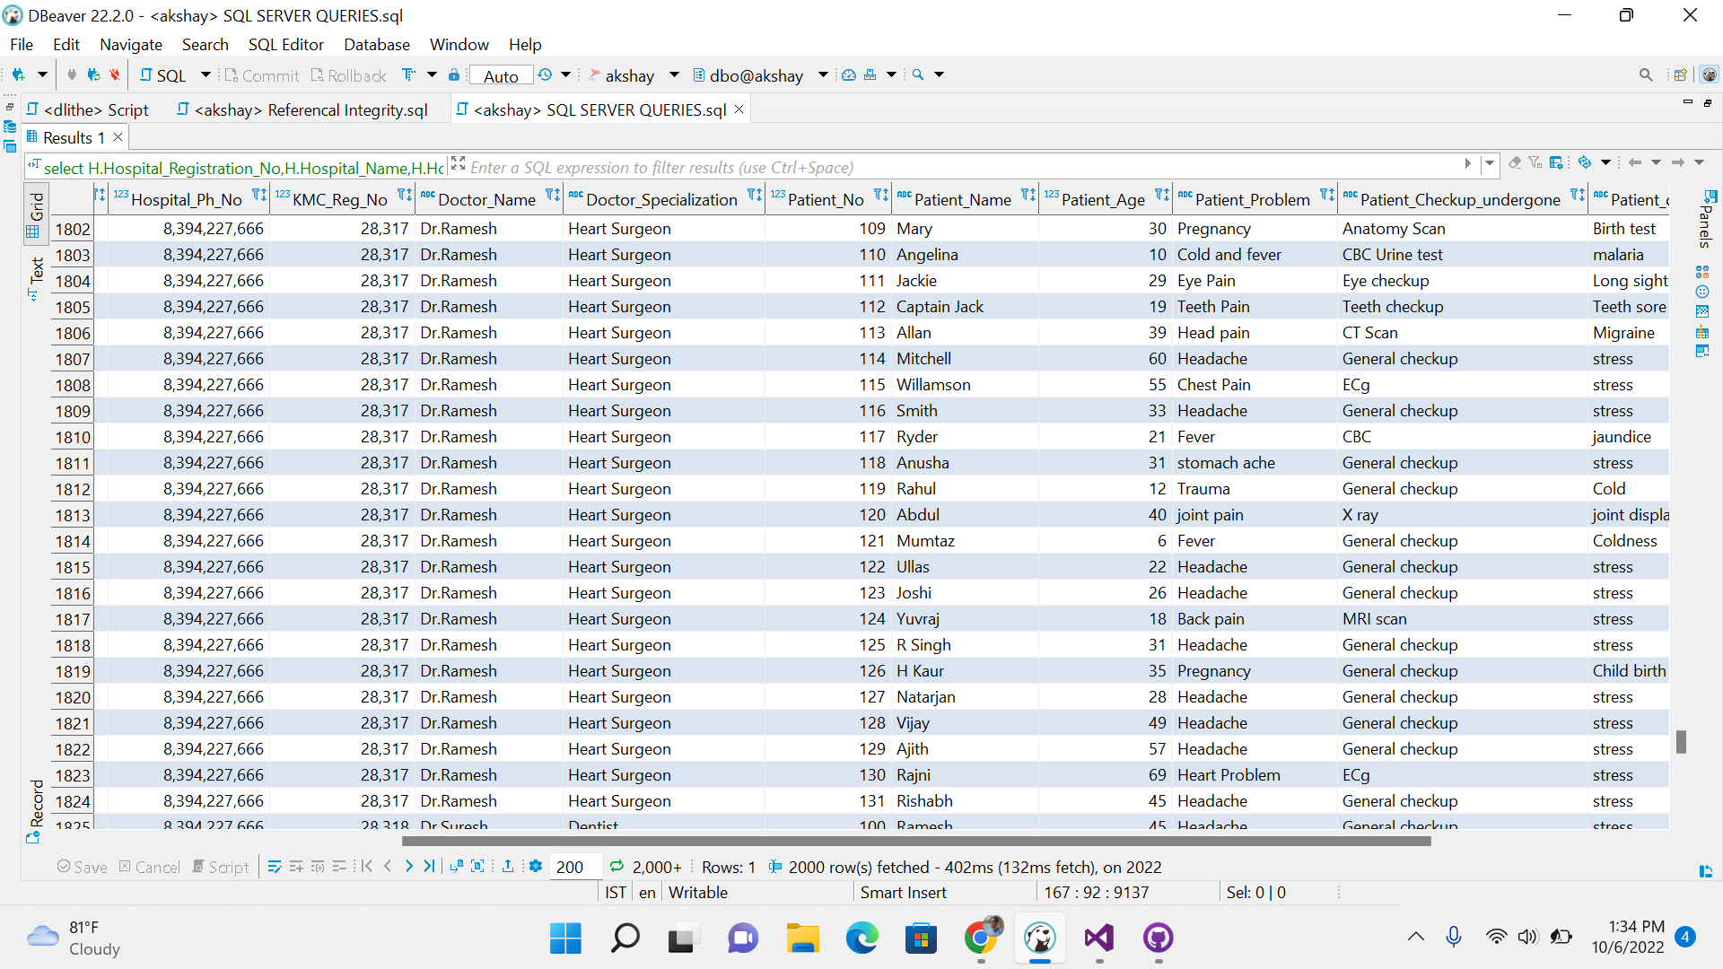5.Cross Join : In the cross join every table columns will get multiplied and cross join happens.

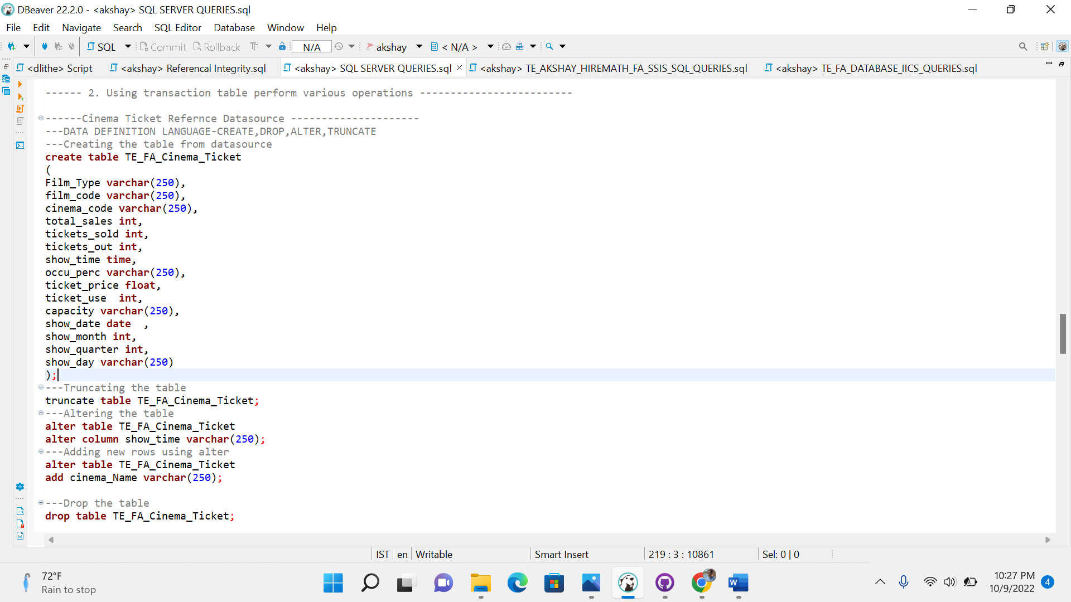

Using given cinema ticket data source performing DDL,DM,DQL.

Creating the table , truncating the table , altering the table.

Inserting the data to created table and updating the table. DQL command selecting the table.

Using other data source of Patient covid health care performing DDL,DML,DQL operations.

Given Data source extracting the data from excel to transformation data conversion to the OLEDB destination.